# Solution 1:-

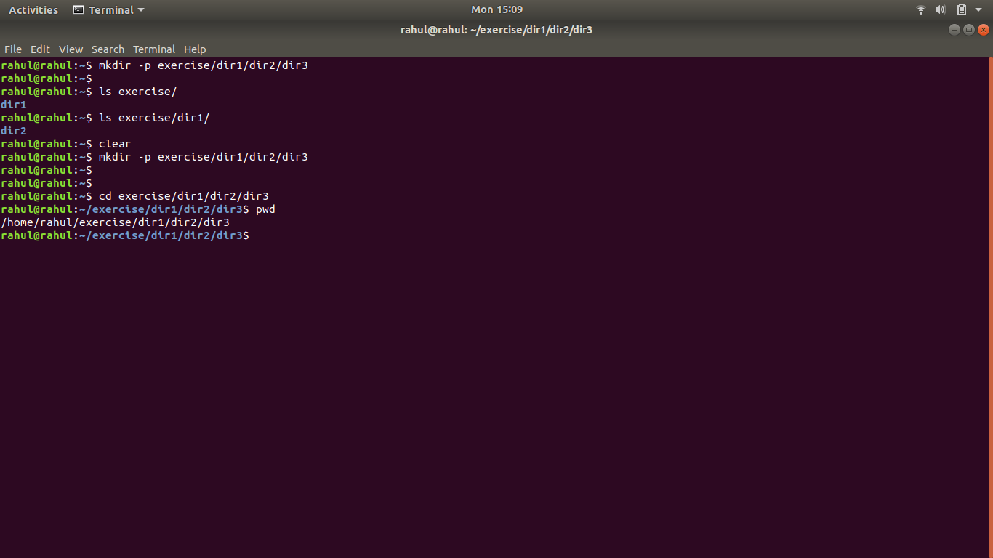

mkdir -p exercise/dir1/dir2/dir3

# Solution 2:-

touch ./exercise/dir1/dir2/{empty1,empty2}

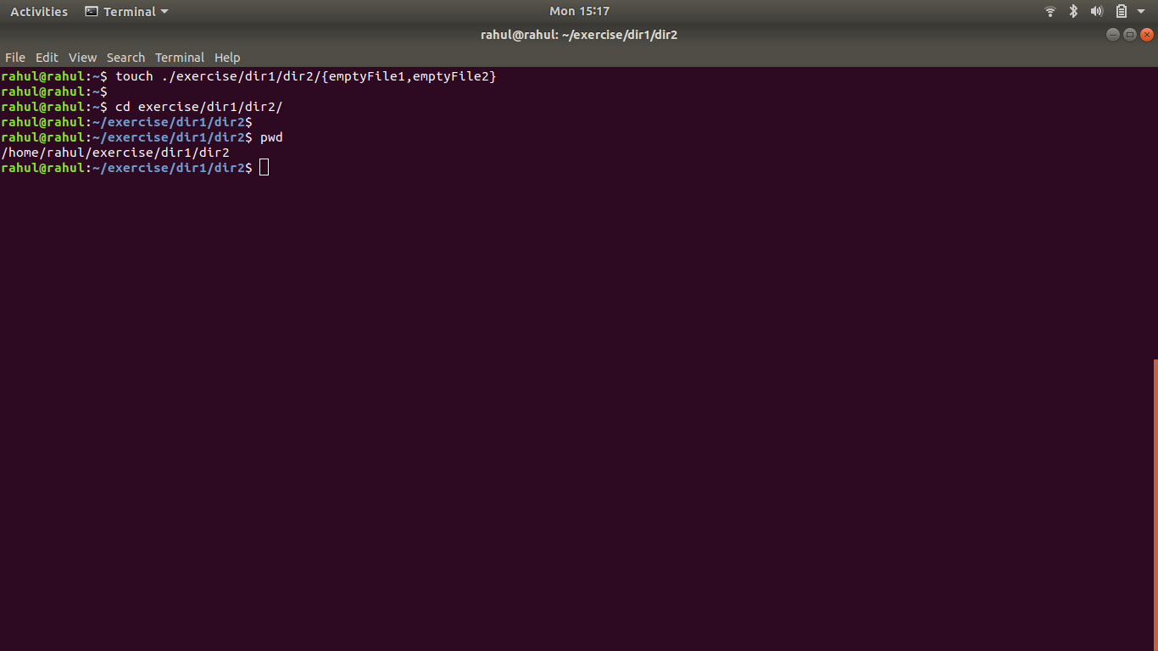

# Solution 3:-

echo “hello world” file1.txt

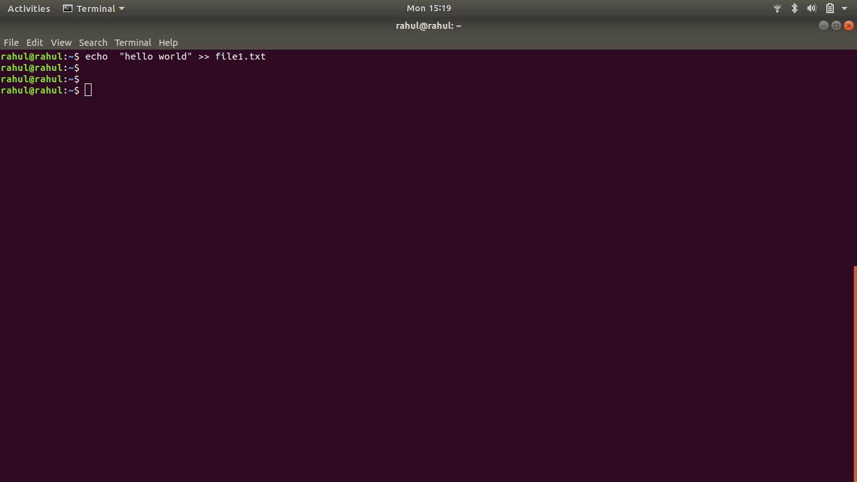

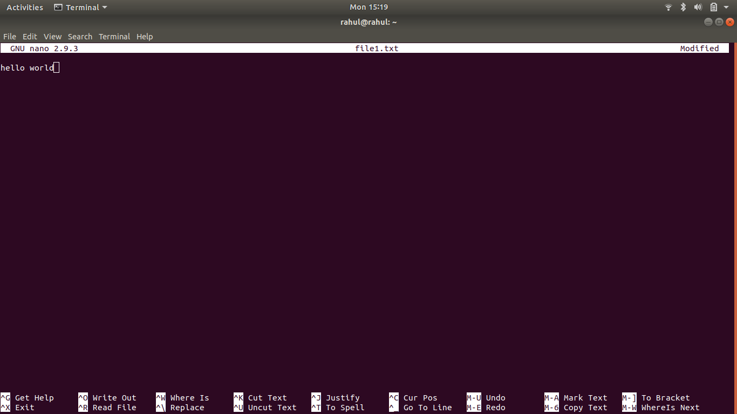

# Solution 4:-

find ./../../etc/ -name passwd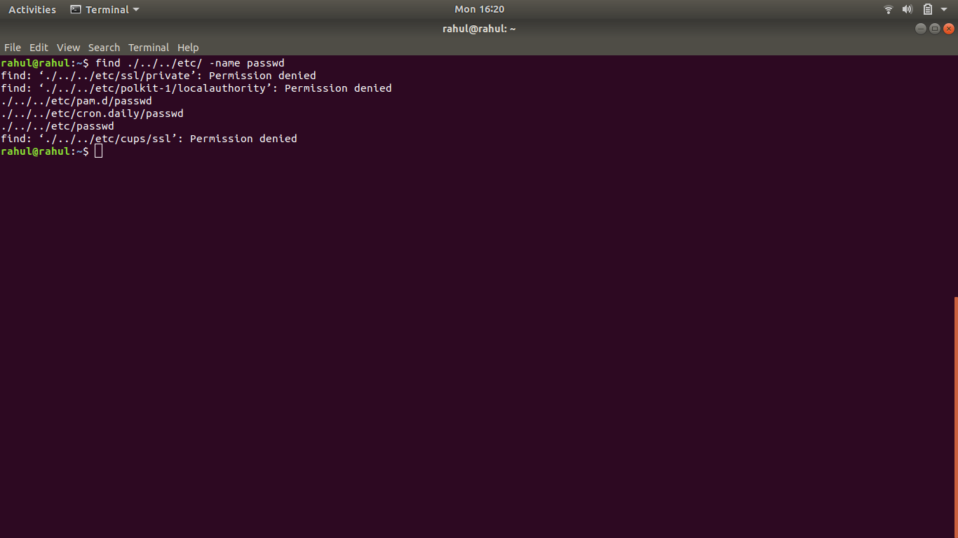

cp ./../../etc/passwd passwd_cpy

mv passwd_cpy passwd_backup

# Solution 5:-

more passwd_backup

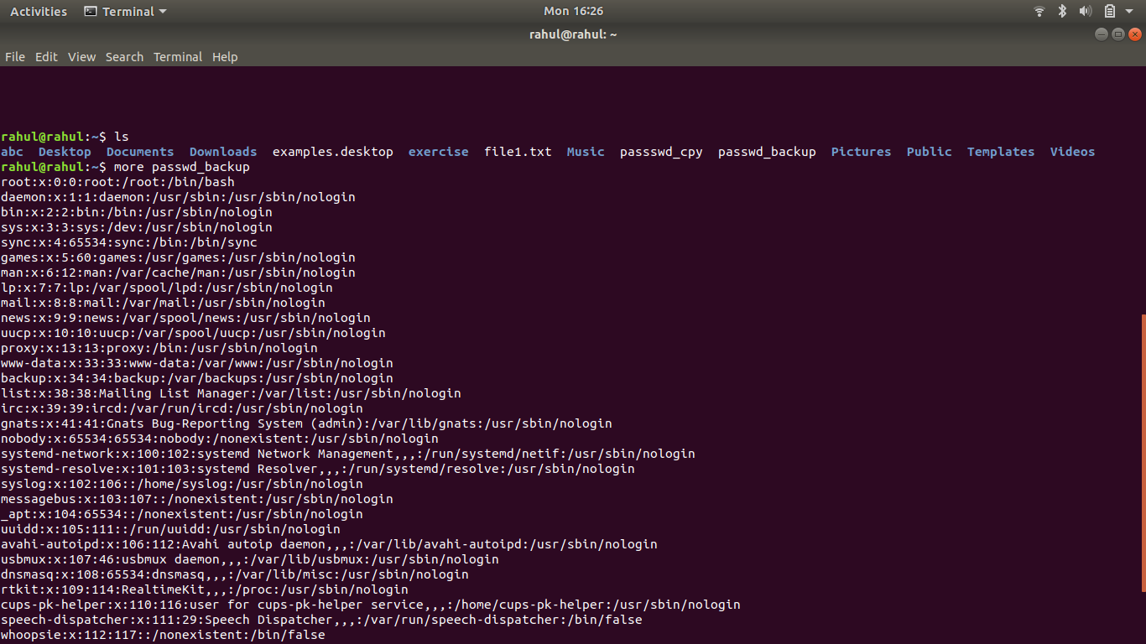

less passwd_backup

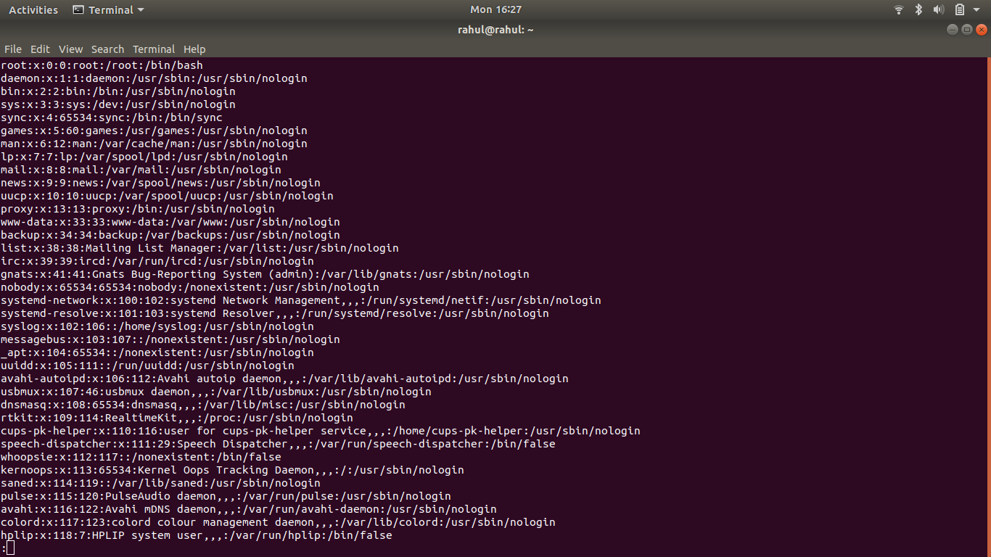

Cat passswd_cpy passwd_backup

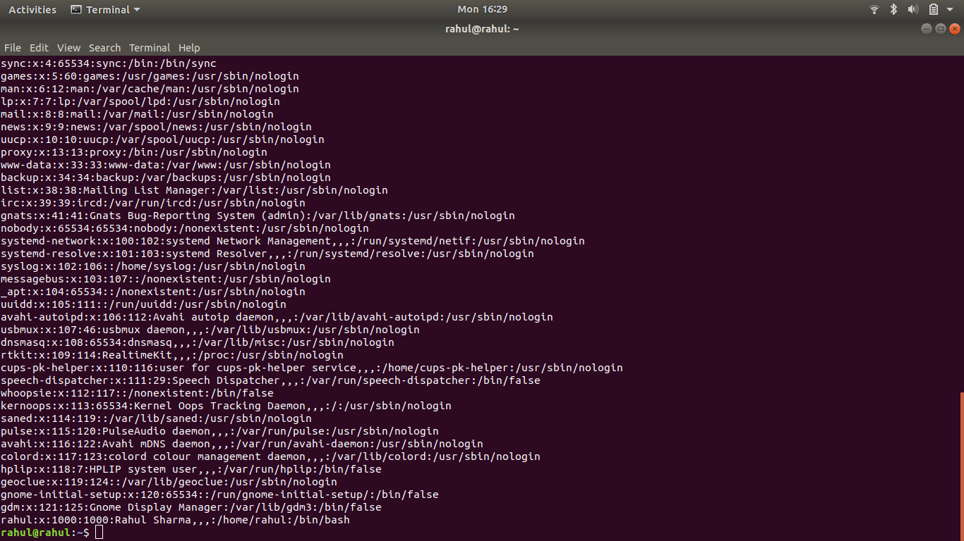

# 

string passwd_backup

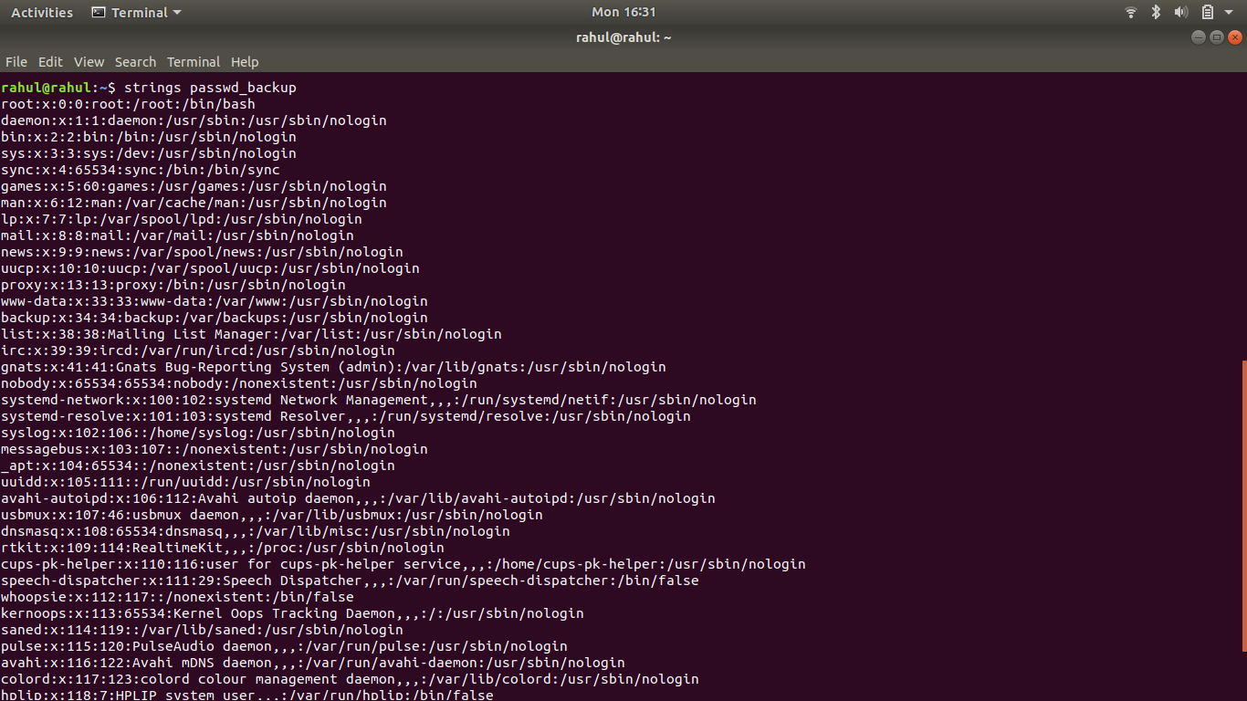

# Solution 6:-

Grep -n “/bin/false” passwd_backup

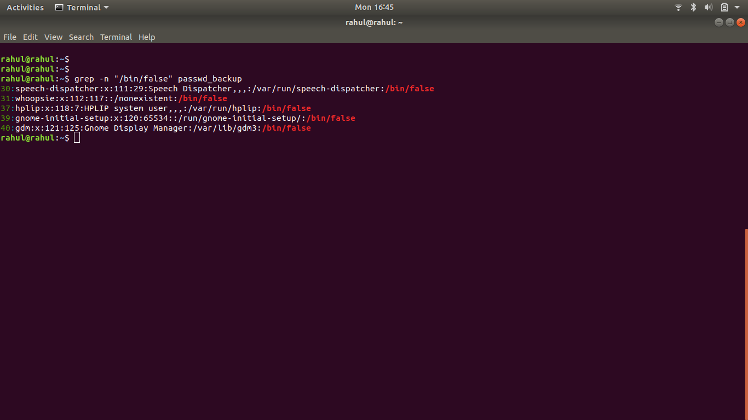

# Solution 7:-

head -5 passwd_backup > output

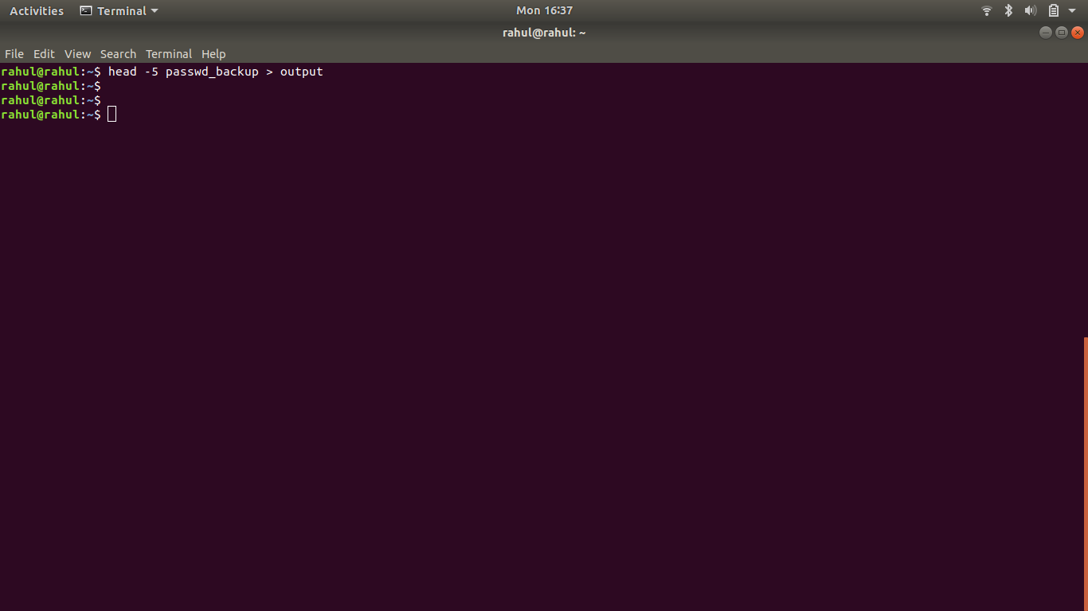

nano output

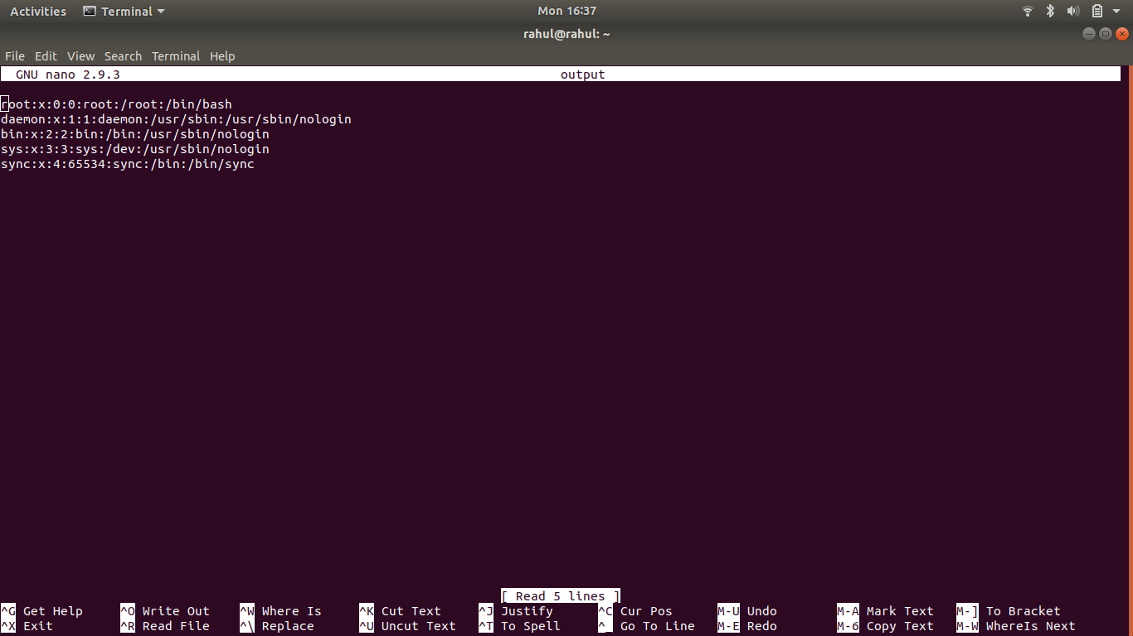

# Solution 8:-

sudo useradd test

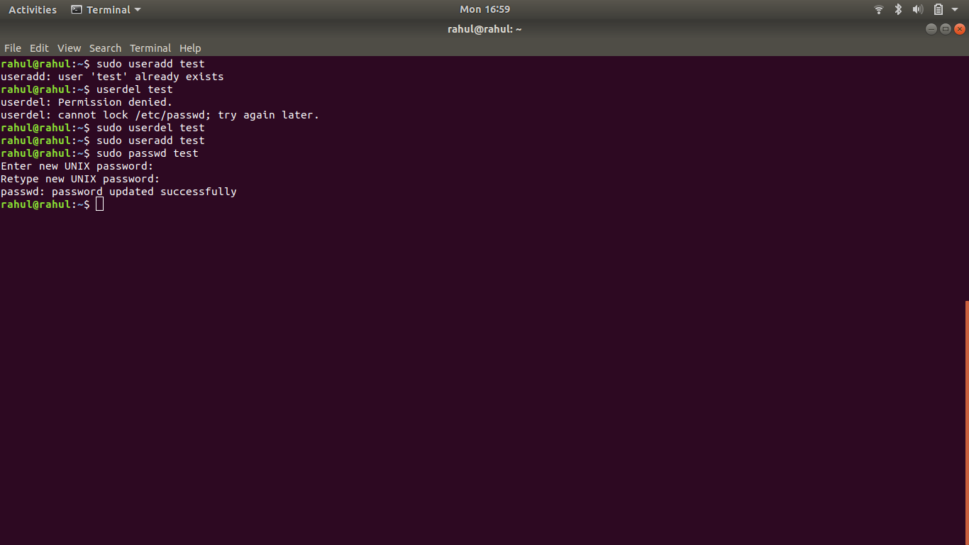

Id -u test

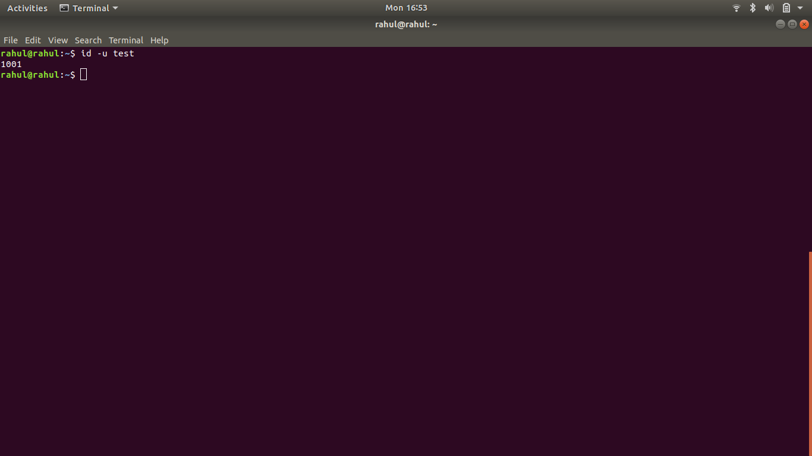

Id -g test

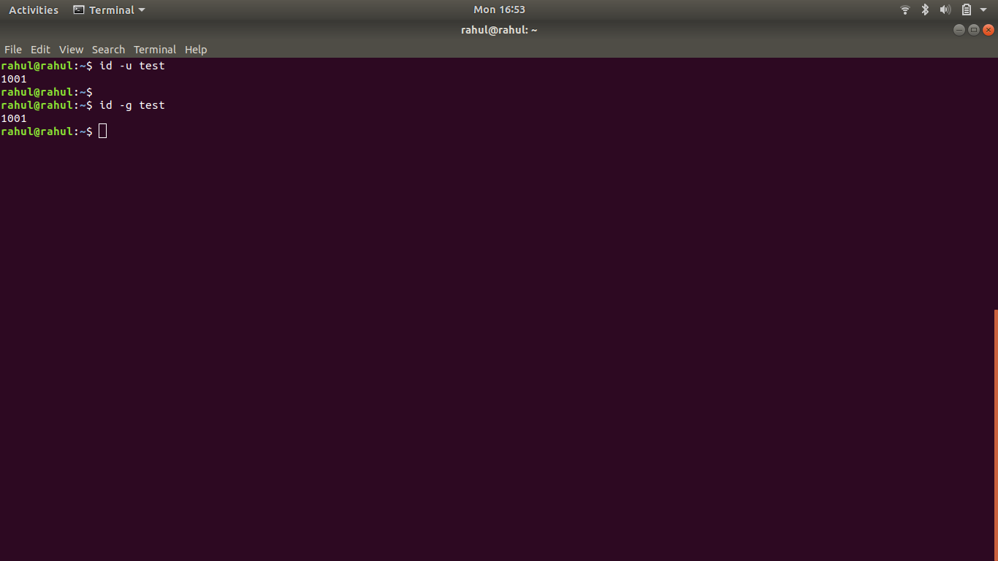

# Solution 9:-

touch /exercise/dir1/dir2/{emptyFile1,emptyFile2}

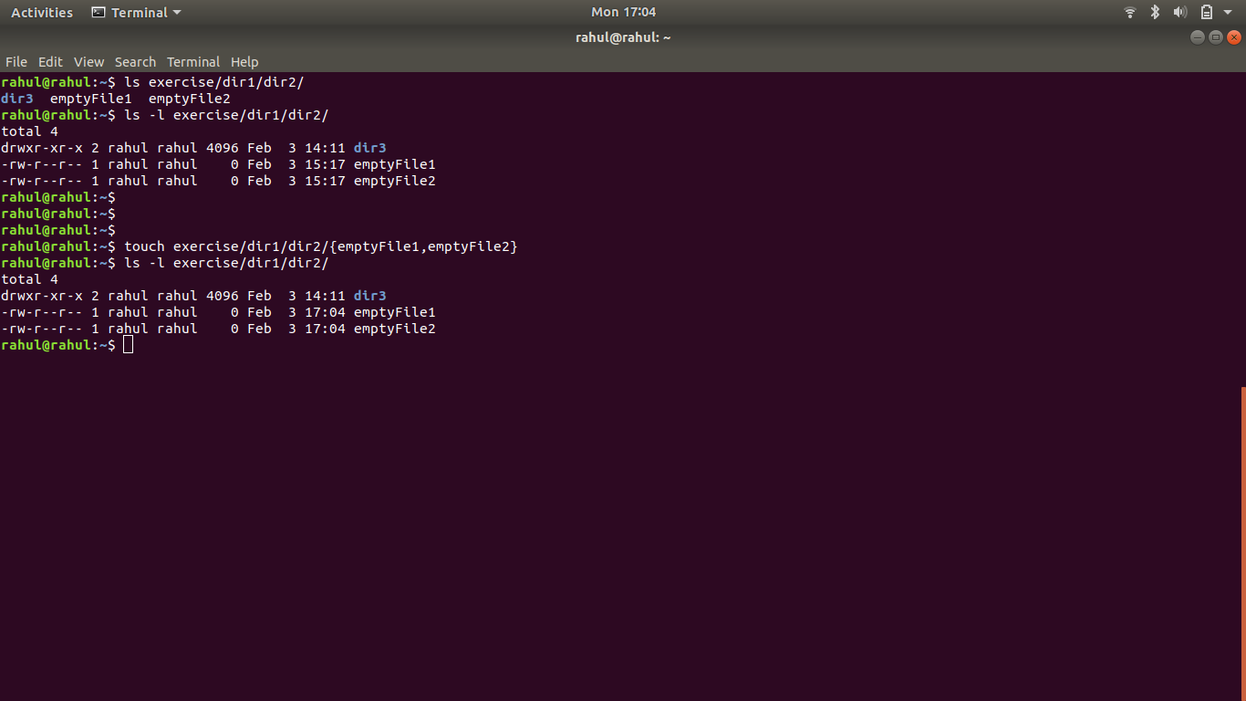

# Solution 10:-

su - test

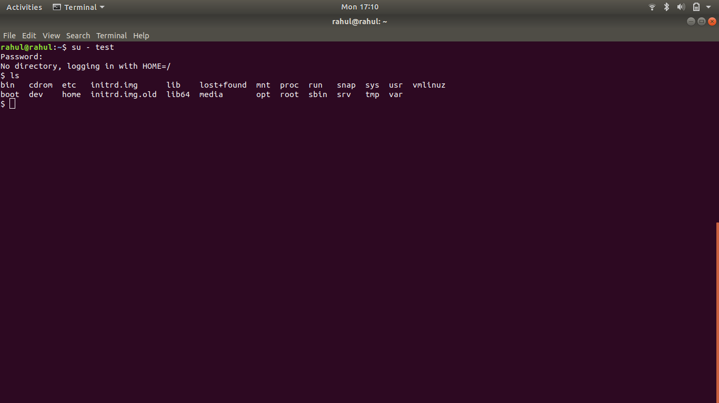

Changing file permissions and making test able to acces the output file

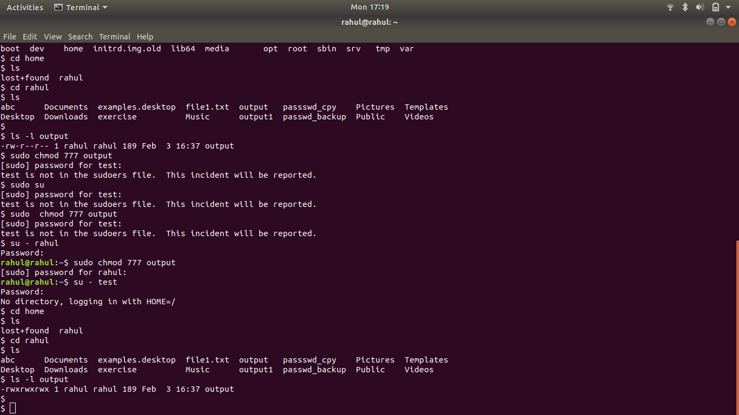

# Solution 11:-

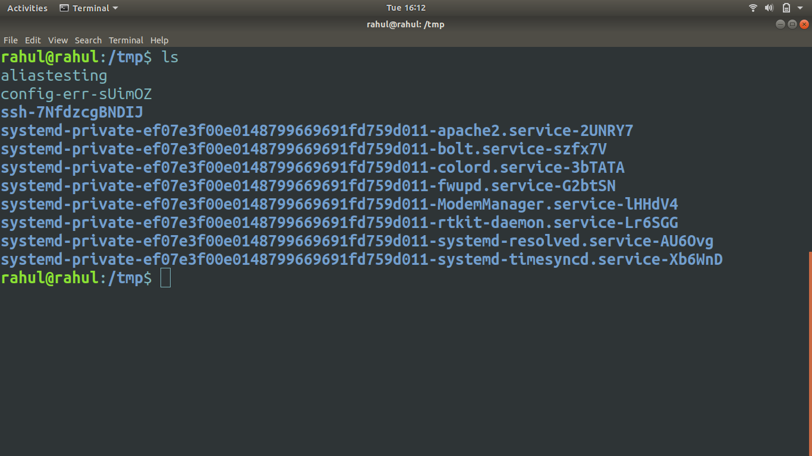

# Solution 12:-

# ****************Doubt***********************

# Solution 13:-

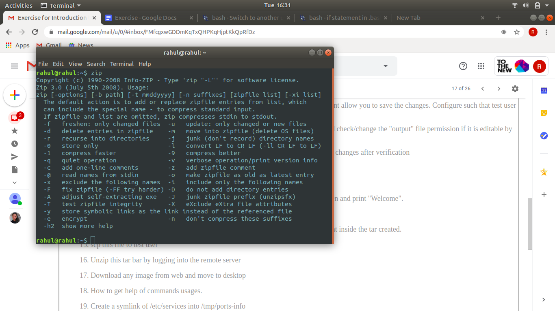

# Solution 14:-

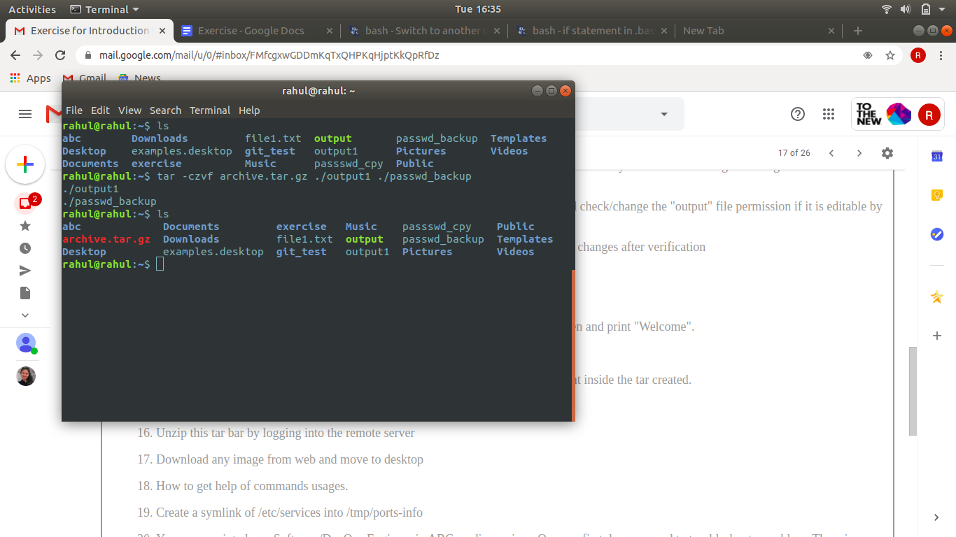

# Solution 15:-

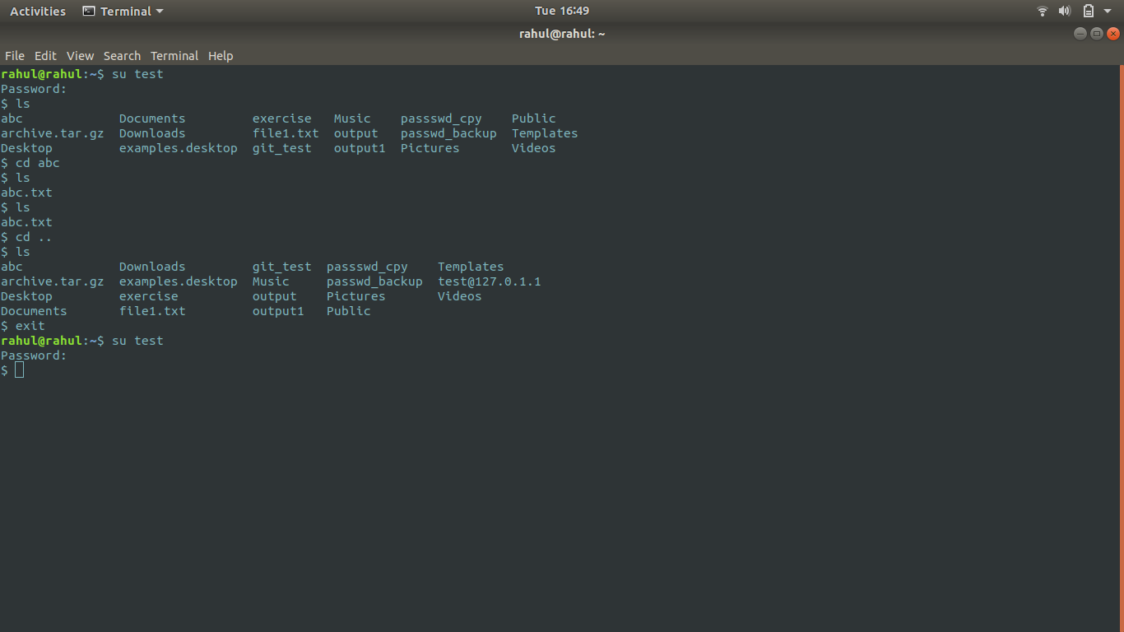

# Solution 16:-

# ****************Doubt********************

# 

# Solution17:-

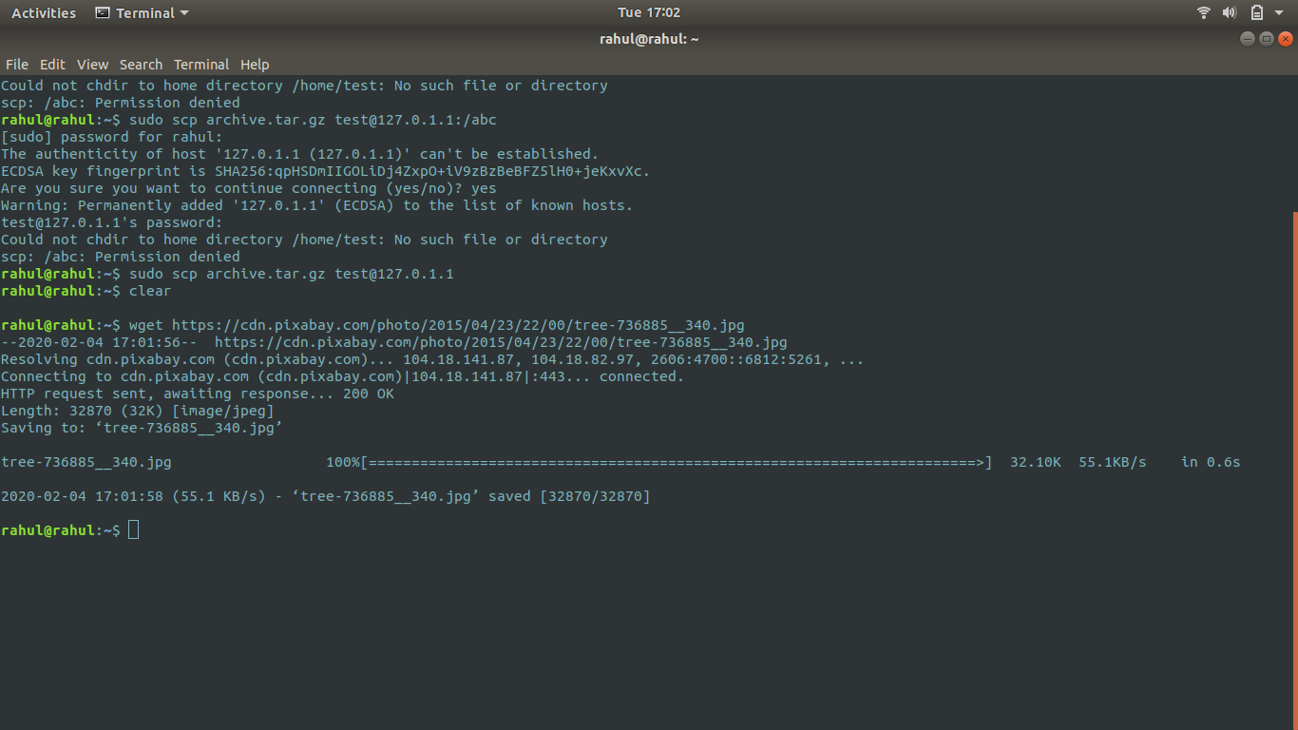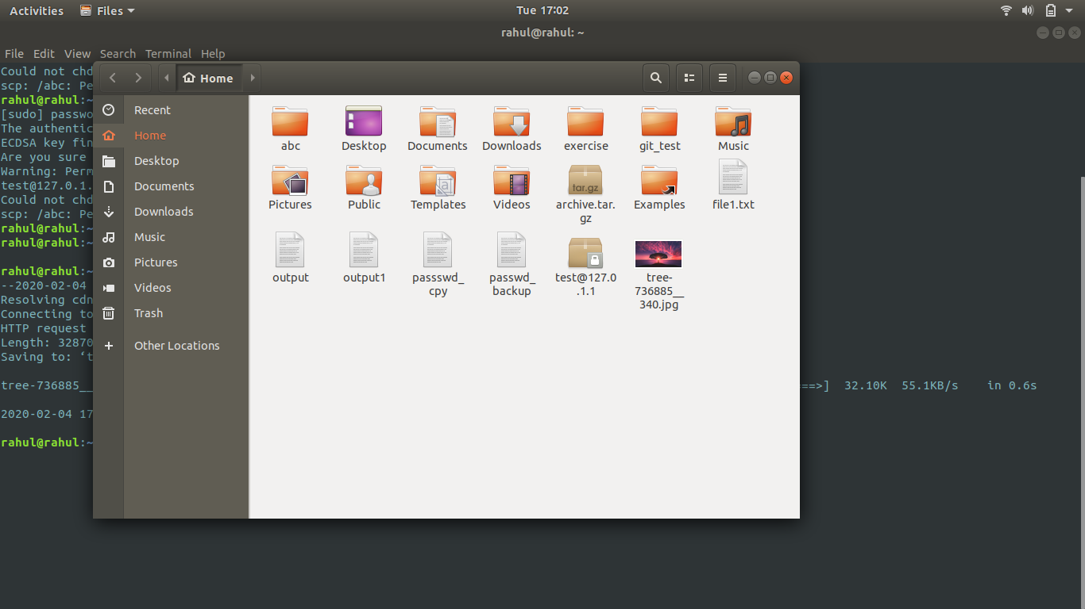

# Solution 18:-

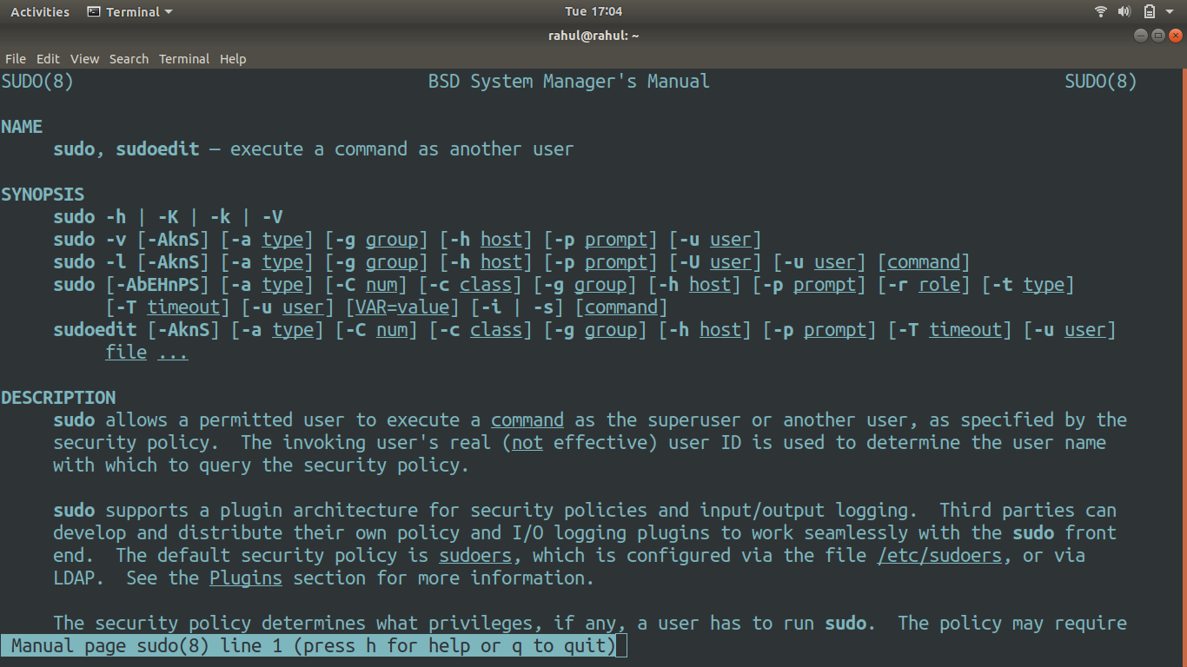

# Solution 19:-

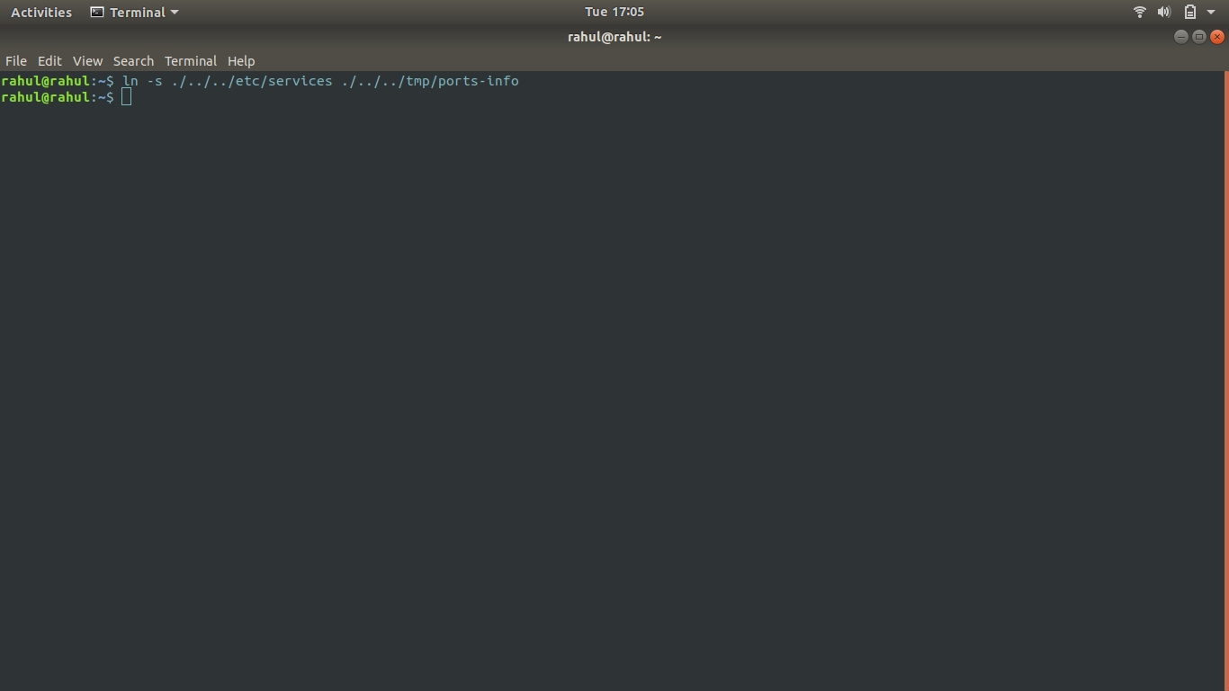

# Solution 20:-

